# Product Management Portal for YourMart

YourMart is a new marketplace startup. YourMart wants Nagarro to create a **Product Management portal** for them where sellers registered with YourMart can upload/add the products they want to sell on YourMart, and the admin users of YourMart can view/update the product information and approve the products to become sellable over their marketplace website yourmart.com.

## Objective

Create a set of web interfaces for YourMart including:

1. **YourMart PMP Seller Panel** – this will be a client-side Angular application using the services exposed by the PMP admin panel app. The Angular app will interact with the web server using RESTful web-services for the seller operations.
2. **YourMart PMP Admin Panel** – a java web app using Spring MVC & JSP pages for YourMart admin users to manage the details of sellers and their products.

## YourMart PMP Seller Panel

### End Users

1. Registered Sellers
2. Non-Registered seller can only request for Registration

YourMart maintains a list of Registered Sellers who are allowed to login to the portal as seller login.

### Non-Registered Seller

#### New Seller Registration

A new Seller can register on the portal by providing following details (all mandatory):

* Company name
* Owner Name
* Address
* Email
* Telephone
* GST number
* Password (must be at least 8 characters long and contain at least one numeric and one special character.)
* Confirm Password (Repeating the password)

When a seller registers initially the Seller status is NEED_APPROVAL and the seller is assigned an autogenerated unique YourMart Seller Id. Such seller appears in a list of new sellers to the admin users, who approves the seller after which they can add product information to the portal.

#### Login

Login with Seller Id and password. Non-registered/Need-approval/ rejected sellers will be shown an error on login.

In case of seller with status NEED_APPROVAL an error message will be shown to the seller that his/her registration is not yet approved.

In case of status REJECTED an error message will be shown that his/her registration has been cancelled and they can contact the YourMart seller services team.

Google Captcha to be included on the login screen.

### Registered Seller View

View for a seller to manage his products that he wants to sell on yourmart.com.

#### Seller Login

Login with Seller Id and password.

Google Captcha to be included on the login screen.

#### My Products List

Paginated List of the products added by the seller. Enable search/filtering of results by product code, product name, status and category. Also enable pagination and sorting on product code, product name, MRP, Suggested Selling Price (SSP), YourMart Price (YMP).

The product list will show following product details:

* Primary Image (in thumbnail format)
* Seller Product code
* Name
* Status (NEW, APPROVED, REJECTED, REVIEW)
* Categories
* MRP
* SSP
* YMP

#### Add new product

Seller can add a new product he intents to sell on yourmart.com. Seller will provide the following details for a new product (the fields with * are mandatory)

* Seller Product Code*
* Name*
* Short description*
* Long Description
* Dimensions
* Categories (From a set of predefined categories maintained by YourMart Admin users)*
* MRP*
* SSP
* YMP*
* Primary Image*
* Gallery images- a set of product images
* Usage instructions (pdf document)
* Product Attributes – set of product attributes – name value pairs - describing a specific product

When a new product is added by a seller it is assigned a unique YourMart Product id and also an initial status of NEW until it is approved by any of the YourMart Admin user. Once it is approved the status is set as APPROVED.

#### View/Edit Product Detail

The seller can view/edit the details of his product including all the above details he provided at time of product creation. Also, the seller will be able to see the comments added by YourMart admin around the product info in case of REJECTED state of product.

The Primary Image of the product will appear as a default image and other images will show up in a carousel below the primary image. (Refer the image below for the same). In case the seller makes any changes to product information the product status changes to REVIEW.

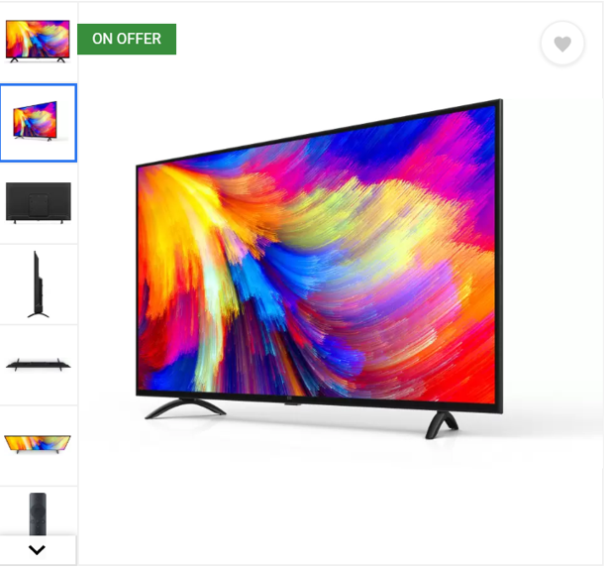

## YourMart PMP Admin Panel

### End Users

1. YourtMart Admin Users

### Your Mart Admin Users

#### Login

Login with YourMart Id and password.

Google Captcha to be included on the login screen.

#### Sellers List Screen

Paginated list of all the sellers sorted by default on the seller status in the given order -NEED_APPROVAL, APPROVED, REJECTED.

Admin users can

* sort the list of sellers based on seller id and Registration time.
* search the sellers based on a part of company name, owner name, contact number.
* filter the sellers list by status.
* Select multiple sellers with status NEED_APPROVAL to approve them at once.

#### Seller Details Screen

Admin user can view the complete details of the seller and change the status of the seller.

#### Products List Screen

Paginated list of all products of all the sellers.

Admin users can

* sort the list of products by MRP, SSP, YMP, creation/update date.
* search the products by seller product code, name, YourMart product Id.
* filter the products list by status, seller id, seller company name, category.
* Select multiple products and APPROVE their status at once.

#### Products Details Screen

The Admin user can view all the details of a product and change the status of the product and provide comments for suggesting some changes required in product data to the sellers. It is mandatory to add the comments in case YourMart admin user changes the status of product to REJECTED from NEW or REVIEW state. UI design should be similar to the Product Details screen of the PMP seller application.

#### Categories Management Page

A paginated list of existing categories with option for admin user to create/edit categories details in a popup view. Also, the admin user can remove a category only in case it does not contain any product.

## Bonus Question

* Create a backend job which should trigger email to all YourMart Admin users every midnight with a list of products with status NEW/REVIEW since more than 5 days.
* Send an email to seller whenever a YourMart admin adds some comments on his/her products.

## Important Notes

* All the data for the sellers, YourMart admin users, product, categories, comments etc. will be maintained on the server side, not on the Angular side.
* Angular application will hit the we-services to fetch/add/update the data.
* The UI indicators are just a guideline representation and need not be adhered fully. Please feel free to use your creativity and innovation to create a better user experience.
* Please follow the general guidelines for restful services. You can refer to the link suggested below.

<https://blog.mwaysolutions.com/2014/06/05/10-best-practices-for-better-restful-api/>

* State clearly your assumptions if any.
* You may go through a webinar around a similar PMP tool to take inputs for the UX journey as well as some background domain knowledge

<https://www.youtube.com/watch?v=72IUtess344>

## Technology Stack

Following technologies should be used to create the application:

* Backend - Java, Hibernate, Tomcat, MySQL
* Web-services – Spring, RESTful
* Frontend - Angular 6, HTML, CSS, Google captcha, JSPs, Bootstrap, Javascript/JQuery